DS Assignment 8
By Gavisht Singh
Q1
#include <iostream>
using namespace std;
void details(){
cout<<"\Gavisht Singh \t1024030358 \t2C24";
}
struct Node {
int data;
Node* left;
Node* right;
Node(int x) : data(x), left(NULL), right(NULL) {}
};

void preorder(Node* root) {
if (!root) return;
cout << root->data << " ";
preorder(root->left);
preorder(root->right);
}

void inorder(Node* root) {
if (!root) return;
inorder(root->left);
cout << root->data << " ";
inorder(root->right);
}

void postorder(Node* root) {
if (!root) return;
postorder(root->left);
postorder(root->right);
cout << root->data << " ";
}

int main() {
Node* root = new Node(1);
root->left = new Node(2);
root->right = new Node(3);
root->left->left = new Node(4);
root->left->right = new Node(5);

cout << "Preorder: ";
preorder(root);

cout << "\nInorder: ";
inorder(root);

cout << "\nPostorder: ";
postorder(root);
details();
}
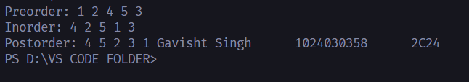

Q2
#include <iostream>
using namespace std;
void details(){
cout<<"\Gavisht Singh \t1024030358 \t2C24";
}
struct Node {
int data;
Node* left;
Node* right;
Node(int x) : data(x), left(NULL), right(NULL) {}
};

Node* insert(Node* root, int key) {
if (!root) return new Node(key);
if (key < root->data) root->left = insert(root->left, key);
else root->right = insert(root->right, key);
return root;
}

//// (a) Search: Recursive
Node* searchRecursive(Node* root, int key) {
if (!root || root->data == key) return root;
if (key < root->data) return searchRecursive(root->left, key);
return searchRecursive(root->right, key);
}

//// (a) Search: Non-Recursive
Node* searchIterative(Node* root, int key) {
while (root) {
if (key == root->data) return root;
root = (key < root->data) ? root->left : root->right;
}
return NULL;
}

//// (b) Maximum element
Node* findMax(Node* root) {
while (root && root->right) root = root->right;
return root;
}

//// (c) Minimum element
Node* findMin(Node* root) {
while (root && root->left) root = root->left;
return root;
}

//// (d) Inorder Successor of a node
Node* inorderSuccessor(Node* root, Node* target) {
if (target->right) return findMin(target->right);

Node* succ = NULL;
while (root) {
if (target->data < root->data) {
succ = root;
root = root->left;
} else if (target->data > root->data) {
root = root->right;
} else break;
}
return succ;
}

//// (e) Inorder Predecessor
Node* inorderPredecessor(Node* root, Node* target) {
if (target->left) return findMax(target->left);

Node* pred = NULL;
while (root) {
if (target->data > root->data) {
pred = root;
root = root->right;
} else if (target->data < root->data) {
root = root->left;
} else break;
}
return pred;
}

int main() {
Node* root = NULL;
int arr[] = {20, 8, 22, 4, 12, 10, 14};
for (int x : arr) root = insert(root, x);

Node* target = searchRecursive(root, 12);
cout << "Inorder Successor of 12: " << inorderSuccessor(root, target)->data << endl;
cout << "Inorder Predecessor of 12: " << inorderPredecessor(root, target)->data << endl;
details();
}
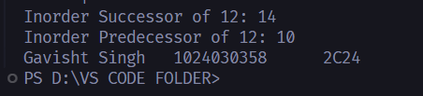
Q3
#include <iostream>
using namespace std;
void details(){
cout<<"\nGavisht Singh \t1024030358 \t2C24";
}
struct Node {
int data;
Node* left;
Node* right;
Node(int x) : data(x), left(NULL), right(NULL) {}
};

Node* insert(Node* root, int key) {
if (!root) return new Node(key);
if (key < root->data) root->left = insert(root->left, key);
else if (key > root->data) root->right = insert(root->right, key);
return root;
}

Node* findMin(Node* root) {
while (root->left) root = root->left;
return root;
}

// (b) DELETE
Node* deleteNode(Node* root, int key) {
if (!root) return root;

if (key < root->data) root->left = deleteNode(root->left, key);
else if (key > root->data) root->right = deleteNode(root->right, key);
else {
if (!root->left) {
Node* temp = root->right;
delete root;
return temp;
}
else if (!root->right) {
Node* temp = root->left;
delete root;
return temp;
}
Node* temp = findMin(root->right);
root->data = temp->data;
root->right = deleteNode(root->right, temp->data);
}
return root;
}

// (c) Maximum Depth
int maxDepth(Node* root) {
if (!root) return 0;
return 1 + max(maxDepth(root->left), maxDepth(root->right));
}

// (d) Minimum Depth
int minDepth(Node* root) {
if (!root) return 0;
if (!root->left) return 1 + minDepth(root->right);
if (!root->right) return 1 + minDepth(root->left);
return 1 + min(minDepth(root->left), minDepth(root->right));
}

int main() {
Node* root = NULL;
int arr[] = {15, 10, 20, 8, 12, 17, 25};
for (int x : arr) root = insert(root, x);

root = deleteNode(root, 10);

cout << "Max Depth: " << maxDepth(root) << endl;
cout << "Min Depth: " << minDepth(root) << endl;
details();
}

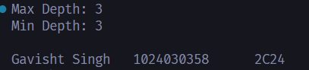
Q4
#include <iostream>
#include <climits>
using namespace std;

struct Node {
int data;
Node* left;
Node* right;
Node(int x) : data(x), left(NULL), right(NULL) {}
};

bool isBSTUtil(Node* root, int minVal, int maxVal) {
if (!root) return true;
if (root->data <= minVal || root->data >= maxVal) return false;

return isBSTUtil(root->left, minVal, root->data) &&
isBSTUtil(root->right, root->data, maxVal);
}

bool isBST(Node* root) {
return isBSTUtil(root, INT_MIN, INT_MAX);
}

int main() {
Node* root = new Node(10);
root->left = new Node(5);
root->right = new Node(20);
root->left->right = new Node(8);

cout << (isBST(root) ? "Valid BST" : "Not a BST");
cout<<"\n Gavisht Singh \t1024030358 \t2C24";
}
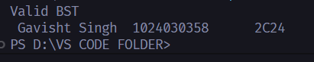
Q5
#include <iostream>
using namespace std;

void heapify(int arr[], int n, int i, bool ascending) {
int extreme = i;
int l = 2*i + 1;
int r = 2*i + 2;

if (ascending) {
if (l < n && arr[l] > arr[extreme]) extreme = l;
if (r < n && arr[r] > arr[extreme]) extreme = r;
} else {
if (l < n && arr[l] < arr[extreme]) extreme = l;
if (r < n && arr[r] < arr[extreme]) extreme = r;
}

if (extreme != i) {
swap(arr[i], arr[extreme]);
heapify(arr, n, extreme, ascending);
}
}

void heapSort(int arr[], int n, bool ascending=true) {
for (int i = n/2 - 1; i >= 0; i--)
heapify(arr, n, i, ascending);

for (int i = n - 1; i > 0; i--) {
swap(arr[0], arr[i]);
heapify(arr, i, 0, ascending);
}
}

int main() {
int arr[] = {4, 10, 3, 5, 1};
int n = 5;

heapSort(arr, n, true); // ascending

cout << "Sorted: ";
for (int x : arr) cout << x << " ";
cout<<"\nGavisht Singh \t1024030358 \t2C24";
}

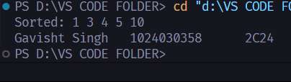

Q6
#include <iostream>
#include <vector>
using namespace std;

class PriorityQueue {
vector<int> heap;

void heapifyUp(int i) {
while (i > 0 && heap[(i-1)/2] < heap[i]) {
swap(heap[i], heap[(i-1)/2]);
i = (i-1)/2;
}
}

void heapifyDown(int i) {
int n = heap.size();
while (true) {
int l = 2*i + 1, r = 2*i + 2, largest = i;
if (l < n && heap[l] > heap[largest]) largest = l;
if (r < n && heap[r] > heap[largest]) largest = r;

if (largest == i) break;
swap(heap[i], heap[largest]);
i = largest;
}
}

public:
void push(int x) {
heap.push_back(x);
heapifyUp(heap.size() - 1);
}

void pop() {
if (heap.empty()) return;
heap[0] = heap.back();
heap.pop_back();
heapifyDown(0);
}

int top() {
return heap.empty() ? -1 : heap[0];
}
};

int main() {
PriorityQueue pq;
pq.push(30);
pq.push(10);
pq.push(50);
pq.push(40);

cout << pq.top() << endl; // 50
pq.pop();
cout << pq.top() << endl; // 40
}
